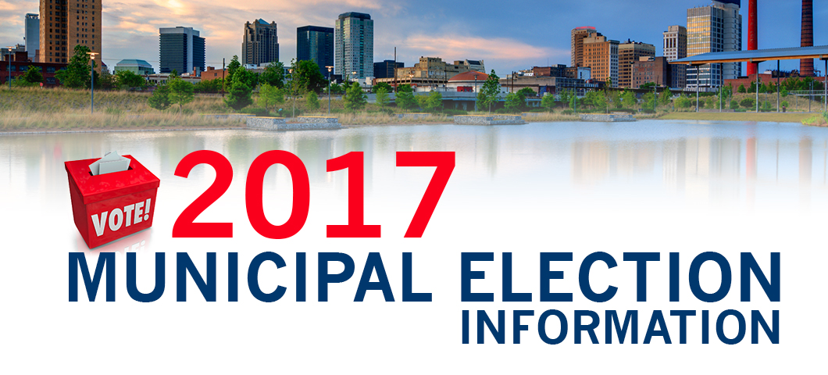

Municipal General Election – Monday October 16, 2017

OFFICIAL Nomination Results
Ward | Name of Nominee | Nominee Status
1 | Garrow, Elaine | Incumbent- Acclaimed
2 | Van Rootselaar, Nick | New
2 | Wallin, Larry | New
3 | Van Rootselaar, Anthony | Incumbent- Acclaimed
4 | Bzowy, Stan | Incumbent-Acclaimed

Elections for Municipal Councilors will be held on Monday October 16, 2017 for Ward 2 in the Brownlee Building located at 4202-50th Street Spirit River.
Contact: Kelly Hudson, Returning Officer
780-864-3500

